Chapter 7: The Emotional System
Problem:
Navigating the complex landscape of emotional and mental health conditions can be an incredibly daunting task, leaving individuals feeling overwhelmed and unsure of where to turn for help. The process of finding the right specialist who can effectively address their unique needs is often riddled with challenges and frustrations. It is disheartening that many people find themselves struggling to locate the support they so desperately need due to a lack of available specialists in their area.
Agitate:
Living with unaddressed emotional and mental health conditions can have a profound and far-reaching impact on an individual's overall well-being. The detrimental effects of these conditions are not limited to just the mind but extend to various aspects of one's life. They can lead to overwhelming feelings of isolation, crippling anxiety, and even hinder personal growth and meaningful relationships. The weight of carrying these unaddressed conditions can be overwhelming, affecting both physical and mental health. It's important to recognize that seeking help is not a sign of weakness but rather a courageous step towards self-care and improvement. By addressing these emotional and mental health challenges head-on, individuals open themselves up to a world of possibilities. They give themselves the opportunity to heal, grow, and thrive in ways they may have never thought possible. Through professional support, therapy, or counseling services, individuals can explore their emotions in a safe environment and develop coping strategies tailored specifically for their needs. Furthermore, taking proactive steps towards addressing emotional and mental health concerns allows individuals to regain control over their lives. It enables them to break free from the shackles that may have held them back from reaching their full potential. Not only does prioritizing mental well-being positively impact one's own life but it also has ripple effects on relationships with others. By actively seeking help for emotional and mental health challenges, individuals can enhance their ability to form deep connections with loved ones. Open communication becomes easier as they gain a better understanding of their own emotions and develop healthier coping mechanisms. In conclusion, living with unaddressed emotional and mental health conditions is not something one should overlook or underestimate the impact of. It is crucial for individuals to recognize the toll it takes on overall well-being – physically, mentally, emotionally – so that they can take the necessary steps towards healing. By seeking professional support when needed and investing in self-care practices consistently, individuals empower themselves to live fulfilling lives where personal growth flourishes alongside healthy relationships.
Solve:
Introducing the Emotionologist - your trusted partner in navigating the complex world of emotions and mental health. Our team of dedicated specialists understands the intricate connections between emotions and mental health conditions, providing you with the support you need to thrive.
No longer will you have to struggle to find a specialist who truly understands your unique needs. With the Emotionologist, we connect you with experienced professionals who are passionate about helping individuals like you overcome emotional challenges.
Take control of your emotional well-being today. Say goodbye to the frustration of searching for specialists and hello to a brighter future with the Emotionologist by your side.
Box 1: An unedited copy of Artificial Intelligence generated text advocating for an emotionologist, a specialist who has studied emotions. Such a word already exists in the English language though I do not recall it ever being previously used.
When I came to begin writing this chapter, I thought I would start with a bit of fun. I was already thinking in terms of the concept of the emotional system. What would such a specialist be called. Obviously an ‘emotionologist.’ I was expecting my word processor to underline in red a spelling mistake, but no it was recognised. Not so the on-line AI writer that I sometimes use. Instead, I asked it to advocate an ‘Emotional Specialist’. Box 1 is the generated text only editing back to replace ‘Emotional Specialist’ with ‘Emotionologist’. I decided to include the whole text because while it is wordy, it encapsulates much of the problems our patients and clients face.
Why does this matter? Most of the mental health conditions that exist are in some way related to the emotions. They may be too intense or switched off or inappropriately expressed. Indeed, it became clear to me that much if not most of the apparently insoluble medical problems had some form of underlying emotional issue, that often went unrecognised. Mind and body are intimately connected. Not least is that intense emotions may have physical effects. I found myself, quite naturally, using the term the emotional system. While colleagues appeared to understand what I was referring to, it did not appear to be a term that they themselves would use. Indeed, ask an online search engine to list the body’s system and depending on the source, about 11 or 12 with minor variations will be quoted. A typical list is given is in Table 1. There may be some variation between different authors, but Table 1 captures the essence of the division. Although the term, ‘the emotional system’ has been used, I could not see its use in the sense that I do, nor in the sense akin to the other physiological systems of the body.
System | Principle Function | Notes
The nervous system | Centre for the coordination and regulation of the body’s sensory and physical apparatus | May be subdivided into the Central Nervous System (Brain and spinal cord); Peripheral nervous system (muscles and the physical sense of touch); autonomic nervous system subdivided into the sympathetic (supporting the fight and flight mechanism) and parasympathetic systems (supporting rest and digestion)
The cardiovascular (circulatory) system | Transportation of water, oxygen, nutrients and other essential chemical substances from one part of the body to another | Sometimes considered to include the lymphatic drainage. A secondary role is thermos-regulation.
The lymphatic system | Draining of excess tissue fluid, immune defence of the body. | Sometimes considered as part of the cardiovascular system because of its relationship to the veins and returning fluid into the main circulation. It is sometimes considered as part of the haemopoietic or immune systems because of its role in defending the body against infection.
The haemopoietic System | Production and elimination of the cellular components of the blood
The respiratory system | The in-drawing of oxygen into the body and the elimination of carbon-dioxide from the blood,
The integumentary (Skin) system | The encapsulation of the body ensuring that water and chemicals are retained, and infection is kept out. | As well as the skin includes the hair and sweat glands.
The endocrine system | Production of hormones which are the chemical messages regulating a wide variety of bodily functions
The gastrointestinal (digestive) system | The mechanical and chemical digestion of food, its absorption into the body and the expulsion of that which has no function | Sometimes the gastro-intestinal system is subdivided into the digestive, biliary and excretory systems. The last is best retained for the urinary system because technically the body is a tube from the mouth to the anus and the undigested food has not been absorbed for it to be excreted. The biliary system which includes the liver, gall bladder and pancreas assists in the chemical digestion of food.
The urinary (excretory) system | The regulation of water and minerals in the body
The musculoskeletal system | Posture and locomotion | Sometimes it I separated into the skeletal system which also has a function of organ protection and the muscular system
The reproductive system | Production of reproductive cells and contribution towards the reproduction process. | Unique in that it is the only system that is structurally different according to gender. Arguably, it perhaps is best thought of as compatible half-systems in males and females as its principle function can only be fulfilled when the two halves come together.
The immune system | The body’s defence against infection
Table 1. A list of the recognised physical systems. There is an overlap. Included are the principle functions though there are many here not included. Some organs may be part of 2 systems, e.g., the lungs are not only respiratory organs but also part of the cardio-vascular system.
In a biological sense, a system is a complex network of interconnected structures and processes that work together to maintain a specific functioning of the organism. It encompasses various levels of organization, from the molecular level to the whole organism.
To understand this concept, let us take a look at two examples: the cardiovascular system (CVS) and the nervous system (NS). The CVS is described in Table 2, so in the text here I will focus on the NS using Man, Homo sapiens as the example.
The NS has only one organ, the brain. Its role is to co-ordinate the complexity of living to ensure survival and safety. The rest of the system is its interconnections which usually are between the brain and all parts of the rest of the body. For ease of use, ‘the rest of the body’ is often called ‘the periphery.’ The ‘periphery’ generally and most accurately refers to the limbs but sometimes it may include more central structures of the torso. The brain itself is also a sea of connections, linking two or more different specialised areas within the brain. The connections from the brain to the periphery is through the spinal cord. Some connections, for example the knee jerk reflex elicited by doctors by striking the knee with a tendon hammer, miss out the brain altogether and are only transmitted through the spinal cord.
Sometimes reference is made to subsets of the whole Nervous System, but not always using the term ‘system’ in its most accurate sense. They are best thought of as ‘sub-systems’. The Central nervous System (CNS) consists of the brain and spinal cord. The Peripheral Nervous System is the nerve supply once it has left the spinal cord relaying information to the voluntary muscles; and back to the CNS from the various touch and pain sensors in the skin, muscles, bones, and other tissues. The Sympathetic Nervous System prepares our body for "fight or flight" responses during stressful situations by increasing heart rate, dilating blood vessels, and promoting the release of stress hormones like adrenaline. In contrast, the Parasympathetic Nervous System aids food digestion and helps restore our body to a calm relaxed state. Together the Sympathetic and Parasympathetic Systems are referred to as the Autonomic Nervous System because much of its action is not under control of the mind and will be occurring involuntarily. In mammalian predator terms, the Sympathetic nervous system is about hunting the food and not becoming food for another, while the parasympathetic nervous systems is involved in the digestion and enjoyment of the food.
In the Nervous System, the basic cellular unit that has the key functional role of transmitting signals, the chemical impulse along its length, from one part of the body to another is the neurone. It has a similar function to the passage of electricity down a wire, but it is very different in process. There are other cell types that act in supporting roles to the neurone. The neurone has a unique shape to enable it to perform. For example, there are just two neurones that carry the signal of light touch from the tip of the index finger to the sensory cortex in the brain. Each neurone axon, the filament carrying the signal is between 1 and 20 microns across, but more than a metre long.
At the macro-molecular level is a lipo-protein called myelin. This is important for the peripheral nerves that need to respond rapidly. Myelin covers the neurone along the length of the axon allowing the chemical impulse to operate much more quickly. But myelin Is not produced by the neurone. Rather it comes from the cell membrane of the Schwann cell wrapping its cell membrane containing the myelin around the neurone. The Schwann cell, one of the nervous system’s supporting cells. The cell membrane can be thought of as a cellular organelle.
Many neurones together form a bundle which is the visible nerve and is the nerve tissue. Other examples of nerve tissue would be the grey matter in the brain or the limbic system. The latter is a part of the brain involved in our emotional responses and is not a true system as described here.
Some organs may be part of two systems. The ovary is both an endocrine and a reproductive organ. The pancreas is both endocrine and part of the biliary system.
Structure | Description | Example | Function | Image
Organism | A largely independent entity that has an organised structure, and that can exhibit the properties of life. | Homo sapiens | Generally, to survive, be safe and reproduce. For Humans additionally as custodians of the planet and to make our world a better place to live in. | 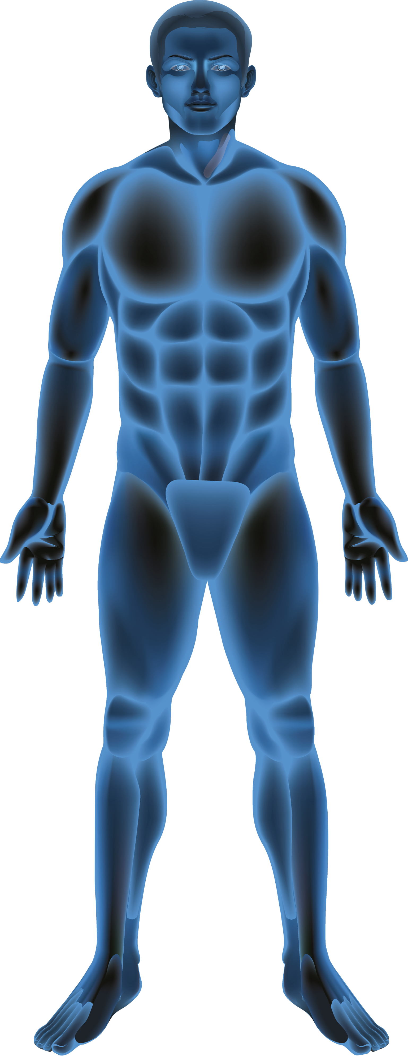
System | a complex network of structures and its connections that work together to carry out a well-defined task. | Cardio-vascular System | To pump blood around the organism with e.g., its oxygen, nutrients, antibodies and hormones | 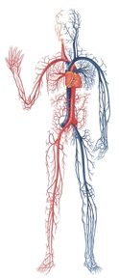
System Connections | The structure and means by which the physical components within the biological system communicate with each other. | Blood  vessels | The channels containing the blood and the nutrients.
Organ | a visibly distinct structure forming a functional unit specialized to perform a particular function. | Heart | The blood’s pump mechanism | 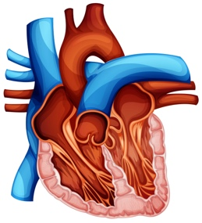
Tissue | a uniform aggregate of cells, found together that have similar structure and function. | Cardiac  muscle | A circular sheet that surrounds the heart chamber that when contracts, reduces the heart chamber size thus squeezing the blood through and out of the heart | 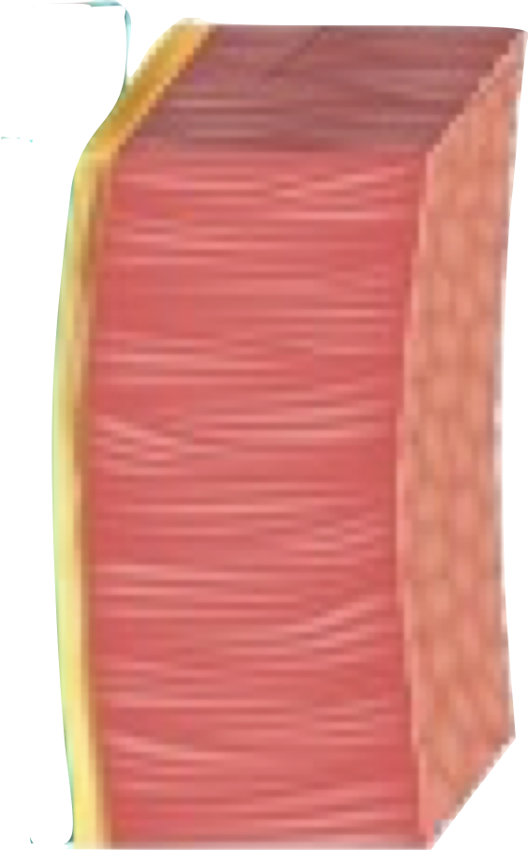
Cell | The basic unit of life with semi-independent existence | Heart  muscle  fibre | The single cell that rhythmically shortens and relaxes | 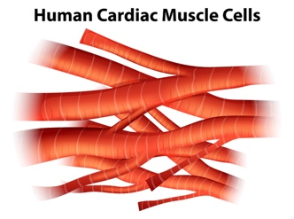
Organelle | a specialized subunit, within the cell, that has a specific function | Mitochondria | Uses oxygen to metabolise glucose and create energy for the pump to work | 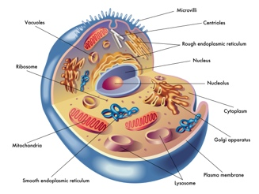
Macromolecule | a very large molecule that has properties that give structure and function to whatever they constitute | Proteins |  | 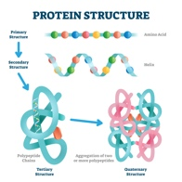
Table 2. The Hierarchical structure of a vertebrate animal starting at the top with the whole organism down to the macro-molecular level. A vertebrate organism is comprised of many systems each containing 1 or more organs with its connections. These are made from various tissues that are composed of many cells. Within these are organelles that are created from macromolecules. The illustrations are courtesy of depositphotos.com and have either been included unmodified or adapted.
Having established the general principle of what is a system, what it does and how it does it, we can now ascertain what comprises the Emotional System. There is a lot.
One of the questions I enjoyed asking my medical students and trainee GPs, perhaps as a kind of a tease, but also to encourage them to think, is why do we have emotions? About half the time I would see a blank face on which I would further ask, “Are they a kind of test in life, there to challenge our self-control?” The answer is of “course not”. They are there to help guide us into making the right choices in life and to optimise the body to carrying out those choices. Of course, primarily this will be for primitive man as a hunter-gatherer, to help him and his tribe survive. They must be viewed in this light. But that does not necessarily mean that in the 21st century the same emotions cannot be used to lead us into making wise decisions and healthy lifestyle choices.
When describing physiological processes, it is very easy to slip into tautology. Tautology is the scientifically lazy approach of giving meaning and purpose to something that has no concept of meaning and purpose. When a function is described, it is our interpretation of the benefits of the action we observed as the outcomes of its operation. Those benefits will have arisen because of the increased survivability by having that outcome. So, when I or anyone else says that that we have emotions, and their purpose is to help us make decisions, that of course is not precise. We have emotions and we have the ability to use them productively to make better decisions.
Under stress we have an emotional response, so we need to consider the effects of stress. Perhaps the easiest way is to take into account the organs and connections, see what is affected when the emotions are fully manifest and what becomes disturbed amid some of the stress related medical conditions. Perhaps linguistics can also help us? Ultimately the test may be what does our would-be emotionologist need to be familiar with. Looking at Figure 1, it presents a way of thinking of the relevance of the organs and tissues to the Emotional System. The core details are the emotions themselves followed closely by the Direct effects. The primary consequences are outcomes because of the Direct Effects. Secondary consequences are more distant outcomes. Our emotionologist needs not only to have a familiarity and mastery up to and including the primary consequences but also to be aware of the secondary consequences. I am not going to be too pedantic into differences between the groups and the precise content of which organ fits into which group, other than if the effects are too far removed from the core, they will be excluded.
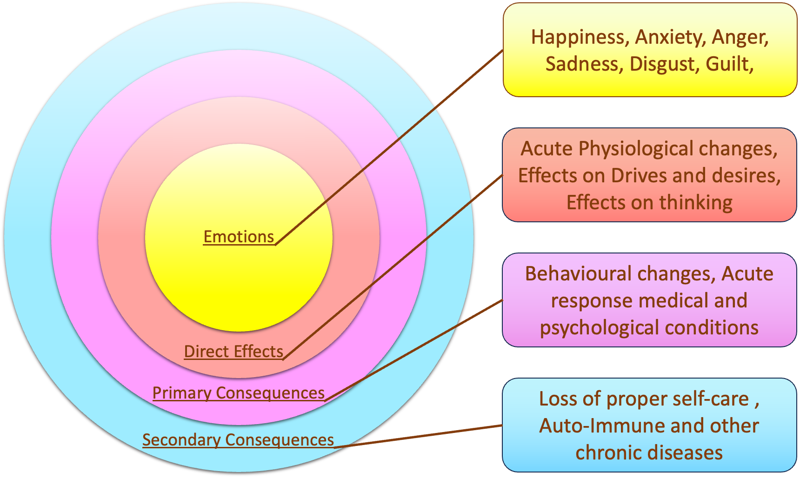
Figure 1. Addressing the Emotions and their consequences. The Emotional System will include anything in which the emotions have direct effects and therefore may also have primary consequence.
We will start with the emotions themselves. They are perceived within the brain. From there the system spreads out and has three broad components to it. They are:
- The whole of the Nervous system
- The Hypothalamic-Pituitary-Adrenal axis
- Psycho-neuro-immunology
Starting with the Nervous System, there are motor nerves going to the muscles and these can tense up under stress. The phrase “I am feeling tense today” may be a reflection of the mind, the muscles, or both. There are sensory nerve endings, but these are only triggered when there is a physical condition, such as a fracture. I cannot think of any stress related medical conditions affecting the bones. Thus, the Skeletal component of the Musculo-skeletal system does not appear involved.
There is a nerve supply to much of the Cardiovascular System. The heart is fed by the 10th Cranial nerve, also known as the Vagus Nerve This is part of the parasympathetic nervous system which when active slows the heart down. The arterioles are small blood vessels within the tissues that are the result of the main arteries having already subdivided many times. They have a nerve supply that ends in what are called 𝛼-receptors. These relax the involuntary smooth muscles within the blood vessel wall so that the arteriole becomes wider allowing through more blood.
The lungs, as both a respiratory organ and a cardiovascular appendage is included. It too has a parasympathetic nerve supply. Hyperventilation, or over-breathing, is one psychological condition associated with the lungs. Strictly speaking hyperventilation primarily is not a lung condition. In a state of anxiety there is an over-stimulation by the nerves of the muscles that induce breathing. However, there are in the lungs adrenaline 𝛽-receptors. These are part of the ‘Fight and Flight’ mechanism that when these receptors are stimulated the breathing passages widen allowing more air into the lung. There is an obvious stress related condition manifesting in the lungs, and this is asthma.
The Digestive system has two broad components to it. There is the alimentary tract, also known as the gastro-intestinal tract, and the accessory organs. The full length of the alimentary tract runs from the mouth to the large bowel and anus. It has a parasympathetic nerve supply. Indeed, there is an extensive plexus of nerves within the tract that may be considered an extension of the nervous system. A committed gastroenterologist could be spending much of his time on fending off the psychological conditions within the gastrointestinal tract as he would on the physical diseases of the gut. The range of psychologically based conditions include a dry mouth and a coated tongue, to acid dyspepsia and gastro-intestinal hurry to irritable bowel syndrome all indicate that the alimentary tract in its full length should be included in the emotional system.
The accessory organs of the digestive system include the teeth, salivary glands, liver, gall bladder and pancreas. They too have a parasympathetic nerve supply. Apart from the salivary gland which when a person is under stress, he may report a dry mouth as the parasympathetic input is minimised, they do not appear to have any other direct effects from the emotions and any consequences would be secondary rather than primary. For example, diseases of the liver and pancreas that may have a connection with the mind, the link will be tenuous at best and be mediated through the immune system rather than a more direct route of, which for a counter example, overactivity of the nerve supply causes too much uncontrolled and undiluted acid causing ulcers in turn leads to ulcers.
So, while the gastrointestinal tract is included in its entirety, of the accessory organs, only the salivary glands are to be included. Gum disease may reflect stress, but not the teeth themselves. The gums are best interpreted as part of the lining of the alimentary tract and are therefore already included. The biliary system of liver, gallbladder and pancreas are not.
In the Urinary system the bladder is included but the kidney is not. The kidneys are similar to the organs of the biliary system. They have a nerve supply. Any effects on the kidneys are secondary consequences, for example, due to hypertension. The bladder biologically is similar to the bowel. Urgency of micturition, that is the feeling of needing to rush to the toilet on a half full bladder in the absence of infection may be stress related.
The brain and therefore the mind, has effects on the body, not only through its neurological connections. The second process is governed by what is known as the Hypothalamic Pituitary Adrenal axis (HPA axis) The hypothalamus is part of the brain situated at its base. The actions of the hypothalamus are very much related to keeping the body's physiological systems in balance. Amongst the processes that occur include the secretion of regulating hormones to the pituitary gland.
The pituitary gland situated just underneath the brain sits in its own space in the base of the skull. The pituitary gland is the central component of the endocrine system. It secretes stimulating hormones to all the other endocrine glands in the body so that they in turn can secrete their own relevant hormone. For example, the pituitary gland secretes thyroid stimulating hormone which causes an increase in the secretion of thyroid hormone. Thyroxine from the thyroid gland amongst its effects is to set the metabolic rate of the body. The pituitary gland also secretes luteinizing and follicular stimulating hormones which in a woman are the two hormones that control the ovary to regulate the menstrual cycle.
The HPA is so called because of the adrenal gland which is the gland that helps manage stress. The adrenal gland has an inner medulla and an outer cortex. The adrenal medulla produces adrenaline which is the immediate stress hormone assisting in the ‘fight and flight’ mechanism. The adrenal cortex secretes cortisol which modulates stress lasting for periods of time longer than hour. This then is our second major pathway directly from the brain to the body, that also needs to be considered as part of the emotional system. For these reasons the adrenal gland must be included.
What about the thyroid gland? The healthy thyroid gland with the thyroid hormones in good balance is important but not as a modulator of stress. Thyroid diseases which in a large part are auto-immune, can give rise to major emotional difficulties. Anxiety and depression are symptoms respectively of an over-active and an underactive thyroid gland. I have included the Thyroid gland in Table 3, but in brackets. The testing of the thyroid hormones is an obligatory investigation of physical illness in people with psychological disturbances, is relevant and therefore a matter that our emotionologist needs to consider. But it is not directly affected by stress or the emotions and is therefore excluded.
There are two hormone secreting glands that are not part of the HPA axis. The Pineal gland secretes Melatonin and is the hormone responsible for responding to day-night cycles. The case for its inclusion as part of the emotional system is weak. The circadian wake-sleep cycles are maintained which has its effects on actions and people generally are more emotionally uncontrolled when excessively tired. Low dose Melatonin is a relatively safe medication for children with developmental sleep disturbances. However there will only be a few instances where a specialist may consider Melatonin therapy, and while diseases of the Pineal can occur, they are rare to the point, I cannot recall meeting any patient with a diagnosis of a pineal disorder. I can make the case either way for its inclusion. Perhaps it should be included because a certain mythology has grown around the pineal gland being a third eye. Proper rigorous research of the pineal gland is warranted.
One endocrine gland definitely excluded is the pancreas. The hormone insulin is secreted in response to carbohydrates. There is no connection between the hormones and the pancreas.
The ovaries, which are both reproductive and endocrine organs are included. Stress has effects on Oestrogen levels which is produced in the ovaries. There are further effects on the uterus and reproduction. Menstrual disturbances are often a result of emotional disturbance. The ancients knew this. The word ‘hysteria’ comes from the Greek word ‘Hysteros’ meaning the womb. It was observed that women were more emotional than men and therefore it was due to the obvious difference of women having wombs. The Fallopian Tubes may be involved by being in spasm when the woman has painful periods, and these may be contributed to by stress. And finally, the vagina. Sexual desire including vaginal lubrication is reduced under stress, when the mind is pre-occupied. Taking it altogether we can comfortably conclude that the whole of the female reproductive tract is included as being part of the emotional system.
In the male a good summary article on stress and its effects on testosterone has been written by Joseph Hearnshaw. In short, chronic stress reduces Testosterone levels. The testicles are therefore included. Stress, both acute and chronic reduce libido. During intercourse there is a highly complex interplay between the mind, the sensory innervation of the penis, and the sympathetic and parasympathetic nervous systems. Ask anyone with erectile dysfunction or premature ejaculation and they are likely to agree that emotional factors very much play their part. So, the penis is also included as part of the emotional system.
The third process of connection between the mind and the body comes under the term of psycho-neuroimmunology. This is the study of how matters of the mind can affect the immune system. The process is highly complex and for a detailed understanding is beyond this book. But in summary stress, whether it is from stress that is physical or psychological, both parts of the adrenal glands are stimulated to release Adrenaline and Cortisol. These in turn modulate the immune cells to release chemicals called cytokines. Many people may not have heard of cytokines until the COVID pandemic in which one of the causes of death and long COVID is thought to be a Cytokine release into the lungs.
Like many of the bodies biochemical compounds Cytokines are constantly present fine tuning the body’s immune system. They are primarily stimulated under circumstances of infection which is a physical stress to the body. There are different classes of Cytokines and they have different effects. These include:
- Directing other immune cells toward places in the body where they are needed to fight infection.
- Preventing viral replication once they have invaded a healthy cell.
- Regulating inflammation in the body. Some Cytokines promote inflammation and others dampen it.
- Signalling to the immune cells to kill tumour cells.
- Signalling to the hematopoietic system that stem cells should differentiate specific cell types for example to become specific white blood cells.
- Signalling to the hypothalamic temperature control centre in the brain to set the body’s thermostat to higher than normal.
- Also signalling to the hypothalamus to reduce appetite and induce lethargy.
- With its effects on the brain and neurotransmitters, being implicated in depression and anxiety.
On a personal level patients would often ask me that given every day I saw patients who were ill with infection, how was it that I kept myself healthy? The simple answer to that is that patients would be in the consulting room for between 5 and 10 minutes. They would shed into my atmosphere a dose of whatever virus they had. The viral load was sufficiently large for my immune system to give me protection but also not so large that my immune system would be overwhelmed, and that I would come down with what the patient had.
There were two exceptions of which only either one of them needed to apply. The first was the patient who sneezed all over me and I could feel the virus containing vapour in and around my nose. This happened only about two or three times in all the years but once it did there was nothing more that I could do about it to prevent the onset of the infection. The other situation was when I was rundown and tired. Sore throat would be an early symptom and I would know that my resistance was low and I was vulnerable.
So, taking all these things into account, it is clear that the whole of the immune system should be included as a part of the emotional system.
The last system to be included, is the Integumentary system. The skin has an intimate relationship with both the Nervous and Immune Systems. There are many psychosomatic conditions of the skin including eczema and psoriasis, hydranitis, some forms of alopecia, and pruritus and hyperaesthesia. Hyperaesthesia comes from the normal quiescent nerve sensations not being filtered out by the brain, and therefore achieving a prominence that they would not usually have. Hyperhidrosis is profuse sweating. The link is with the Sympathetic Nervous System. In a ‘fight or flight’ situation or other form of exertional exercise the burning of calories heats the body. Perspiration is one of the methods by which the body cools itself.
The necessity of skin is that it keeps in water, minerals, nutrients and other essential biochemicals. It also keeps out infections and within it has an active immune system. The skin has its accessory structures. These are sometimes referred to as the accessory organs, although relative to the major organs of the body they are somewhat microscopic and dispersed.
Like the sweat glands, hairs also have a thermo-regulatory effect, though this is much reduced relative to our primate cousins. The scalp hairs act like a natural sun hat. It is probably no coincidence that the indigenous of the African continent have hair that is black, thick and curly relative to the Scandinavians in which it is pale, thin and straight. Eyebrows have probably been retained in an evolutionary sense to keep perspiration out of the eyes. They are also important in communication by emphasising certain facial expressions. Nasal hairs and eyelashes are mechanical means protecting the nose and eyes respectively.
While Homo sapiens species has lost much of its hair, the pubic hair has been retained. Presumably there must have been an evolutionary advantage. Possible biological benefits for having pubic hair may include:
- Unlike most other mammalian species which mate in a dorso-ventral position, when copulating in a ventro-ventro position it provides protection against friction that can cause skin irritation in this sensitive area and that ultimately may lead to infection.
- It may help in the evaporation of sweat from around the vulva and groin, again by preventing direct rubbing of skin on skin in the normal skin creases.
- They may act like nasal hairs and eyelashes as a mechanical barrier to infection.
- It signals that the potential mate is of reproductive age, thus preventing the man from wasting his seed on an infertile woman or the woman wasting one of her eggs on a man who is without functioning sperm.
- It helps regulate body temperature locally
- Most controversially, if they exist in humans, they may help trap pheromones providing a subliminal signal to a potential mate.
Putting it all together, in the 21st century whatever benefits that may have been accrued by evolution are neutralised with good hygiene and anti-microbials. Thus, the removal or retention of pubic hair becomes a personal matter for the individual or couple.
In addition to the sweat glands responding to adrenaline, stress can cause hair to grey. Adrenaline activates the stem cells that produce Melanin to migrate way from the hair follicle permanently depleting the pigment producing cells. So, when people say that with they became grey overnight, they are to be believed.
In non-human primates, hair is used as intimacy for grooming and care. In humans, hair has uniquely taken on the role of social identity. One can rapidly determine a person’s cultural affiliations from their hair, its distribution or sometimes the lack of it.
A person’s approach to their integumentary system says much about their identity, values and approach to life. The same is true with skin and body modification. It has taken on a psychological role not exhibited in other animals. In 2022 the global cosmetics market was valued at a staggering $262.21 billion US Dollars. How much of that is for purely psychological reasons, excluding medical reasons? Probably most. Is this a sign of mass melancholia? Possibly. Because of the skin’s direct response to stress, other emotional scenarios, and the person’s psychological sense of self. The integumentary system in its entirety is included in The Emotional System. Table 3 gives a summary of what is included.
System | Organ | Connections
Nervous System | - Brain | Spinal cord, autonomic nervous system consisting of sympathetic and parasympathetic systems, and all peripheral nerves and neurones | 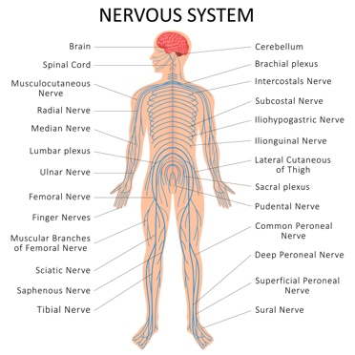
Musculo-skeletal System | - Muscles | Neurones | 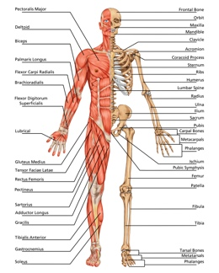
Cardiovascular and Respiratory systems | - Heart  - Lungs | Arterioles | 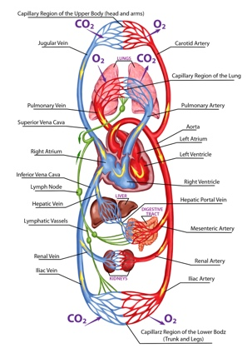
Digestive System | - Alimentary Tract  - Mouth including gums  - Oesophagus  - Stomach  - Duodenum  - Intestine-Small bowel  - Colon-Large bowel  - Accessory organs  - Salivary glands | Parasympathetic nervous system. | 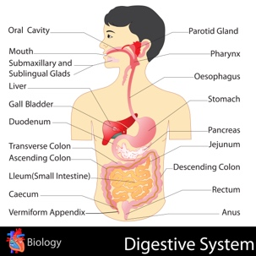
Urinary System | - Bladder | Parasympathetic nervous system | 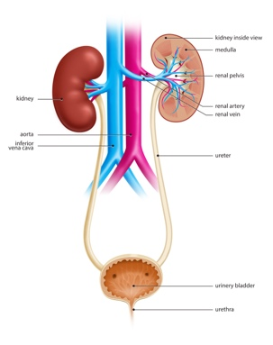
Endocrine system | - Adrenal gland  - Adrenal medulla  - Adrenal Cortex  - (Thyroid gland)  - (Pineal gland) | The hormones Adrenocorticotropic hormone (ACTH), Follicular Stimulating Hormone (FSH), Cortisol, Adrenaline, Melatonin | 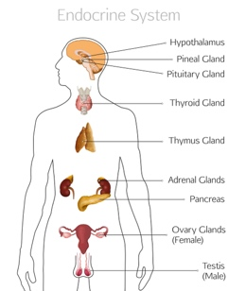
Reproductive System-female | - Ovaries  - Uterus  - Vagina | Oestrogens | 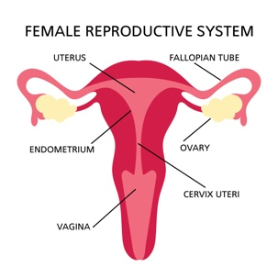
Reproductive system-male | - Testicles  - Penis | Testosterone | 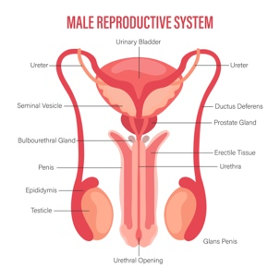
Immune system | - White blood cells | Cytokines | 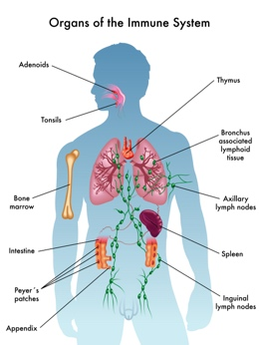
Integumentary system | - Skin and its appendages | Sympathetic nervous system | 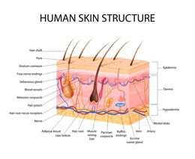
Table 3.A summary of the Emotional System The vector diagrams courtesy of Depositphotos.com.
So, what is the big deal about describing the Emotional System as an entity in its own right? From the personal point of view, it may offer greater clarity when describing emotional responses. For example, it may be semantically more precise to say that the “The Emotional System responds to…” than saying that “The Body responds to….” It would be semantically more efficient to say that “The Emotional System responds by…” than to say that the mind, heart, skin, etc. respond by….”
But I think it has a much wider application than just mine or anyone else’s convenience. In the same way that cardiology implies the study of the cardiovascular system, that is the heart and its connections; Emotionology implies the study of the emotional system, that is the emotions and the organs that they are most associated with.
When studying a large topic, it needs to be disassembled into its component parts. The study can be at the level of students setting out on their educational path or researchers trying to develop new knowledge. Either way it is the same for both, the topic is broken down to derive more detail.
Today we may know that the mind and body are very much integrated. But from a historical perspective this was not so in the mid 17th Century. Taken from the Internet Encyclopaedia of Philosophy, Rene Descartes description of Mind-Body Dualism is paraphrased thus:
- I understand the mind to be indivisible by its very nature.
- I understand the body to be divisible by its very nature.
- Therefore, the mind is completely different from the body.
Using 21st Century understanding, statement 1 above would be true if we refer to the mind as consciousness. We can only experience one package of consciousness at any one moment in time. But we can subdivide the mind into different aspects, for example the conscious and sub-conscious minds. We know that the mind can have certain qualities about it, e.g. emotional, thinking, perceptive, calculating, etc. But to be fair to Descartes, He was of the view that while mind and body were separate, they were very much inter-connected.
But from a study perspective, at the time of Rene Descartes the study of the body, while perhaps still rudimentary by today’s standards was at least underway. For example, by around the same time English physician and anatomist, Thomas Willis had described Diabetes mellitus including its features of frequency of micturition, the sweet tasting urine and features that we would recognise today as diabetic neuropathy. In his day it was still not known that it was a condition of the pancreas. But he was probably not the first to be aware of the condition, with evidence that it was known in the 2nd century AD by Aretaeus of Cappadocia and possibly even earlier.
If we contrast that to the study of psychology, Wilhelm Wundt is generally regarded as the father of psychology. He founded the first psychology laboratory in Leipzig, in 1879 establishing psychology as a science distinct from biology and philosophy.
We thus have two great pillars of knowledge being built from different foundations, in isolation of each other. There are people like me who have tried to fill the gap by starting out as a physician and subsequently learn the psychological aspects. There are others who perhaps have started as psychologists and who subsequently learn about the physical body.
While it does not mean that the knowledge gap at the interface between mind and body cannot be bridged, the numbers of such clinicians are few. It is therefore no surprise that not only is mental health care years behind physical health care, but clinical practice at the interface of both clinical disciplines is even further behind.
The concept of emotionology and emotionologists would be to have available clinicians who would be expert in both the psychological mind and the physical body. Such a clinician would be unbiassed towards either a physical or psychological cause when faced with a patient who presents with say lacking energy, sleep disturbance or impotence; or any of the other multitude of psychological physical conditions. Such a grounding would not be totally new. For example, in the UK to become a state registered nurse the student receives physical health training. To becoming a mental health nurse it is a totally separate course. In New Zealand before becoming a mental health nurse, 3 years of general nursing is the initial requirement before undertaking the mental nurse training.
So, to sum up, for the purposes of this book, the concept of the Emotional System has been described to provide a deeper understanding of how intertwined the emotional side of the person is with the physical and for when needed the physiological consequences of some psychological processes.

The study of emotions as an entity is often referred to as emotionology. This term provides a better definition and clarity when describing emotional responses. It acknowledges that emotions are a distinct system that can be studied and understood.
In the field of education, medical and psychological education are typically separate disciplines. However, they occasionally come together in post-graduate education programs where the study of emotions is explored in depth.
The use of "-ology" in emotionology, similar to other fields such as psychology or biology, signifies the scientific study and analysis of a specific topic. By using this term, researchers and professionals can delve into the intricacies of emotions, their triggers, expressions, and impact on individuals' well-being.
Emotionology allows for a comprehensive understanding of emotional responses by combining knowledge from both medical and psychological perspectives. This interdisciplinary approach enhances our understanding of how emotions function within the human experience.

References:
List of systems of the Human Body: https://en.wikipedia.org/wiki/List_of_systems_of_the_human_body Accessed 16 November 2023
Joung JY, Cho JH, Kim YH, Choi SH, Son CG. A literature review for the mechanisms of stress-induced liver injury. Brain Behav. 2019 Mar;9(3):e01235. doi: 10.1002/brb3.1235. Epub 2019 Feb 13. PMID: 30761781; PMCID: PMC6422711. https://www.ncbi.nlm.nih.gov/pmc/articles/PMC6422711/#:~:text=Psychological%20stress%20is%20associated%20with,sympathetic%20nervous%20and%20adrenocortical%20system. Accessed 30th November 2023.
Prasad S, Tiwari M, Pandey AN, Shrivastav TG, Chaube SK. Impact of stress on oocyte quality and reproductive outcome. J Biomed Sci. 2016 Mar 29;23:36. doi: 10.1186/s12929-016-0253-4. PMID: 27026099; PMCID: PMC4812655. https://www.ncbi.nlm.nih.gov/pmc/articles/PMC4812655/#:~:text=Psychological%20stress%20increases%20production%20of,17ß%20biosynthesis%20in%20the%20ovary. Accessed 4th December 2023.
Joseph Hearnshaw, , 2020, April 14, Stress & Testosterone, https://themenshealthclinic.co.uk/stress-testosterone/, Accessed 5th December 2023
https://www.grandviewresearch.com/industry-analysis/cosmetics-market#:~:text=The%20global%20cosmetics%20market%20size,4.2%25%20from%202023%20to%202030.
René Descartes: The Mind-Body Distinction, Justin Skirry, https://iep.utm.edu/rene-descartes-mind-body-distinction-dualism/#:~:text=I%20understand%20the%20mind%20to,completely%20different%20from%20the%20body. Accessed 13th January 2024.
Karamanou M, Protogerou A, Tsoucalas G, Androutsos G, Poulakou-Rebelakou E. Milestones in the history of diabetes mellitus: The main contributors. World J Diabetes. 2016 Jan 10;7(1):1-7. doi: 10.4239/wjd.v7.i1.1. PMID: 26788261; PMCID: PMC4707300. Accessed 13th January 2024.

https://www.grandviewresearch.com/industry-analysis/cosmetics-market#:~:text=The%20global%20cosmetics%20market%20size,4.2%25%20from%202023%20to%202030.

All this evidence suggests that the skin directly or indirectly responds to the person’s well-being including the emotional state.
https://www.nih.gov/news-events/nih-research-matters/how-stress-causes-gray-hair#:~:text=Sympathetic%20nerves%20extend%20into%20each,the%20stem%20cells%20to%20activate.

Move the following to Appendix on Societal suggestions
We have psychiatrists, psychologists, neurologists, general physicians, physiologists and others all who have to manage people and their emotionality but without further training and education in the areas that they are lacking, almost none have a total mastery across the wide spectrum of emotional conditions

whole ent consists of the heart, blood vessels, and blood. It is responsible for transporting oxygen, nutrients, hormones, and waste products throughout the body. At a cellular level, proteins within red blood cells bind to oxygen molecules and carry them to tissues.
Moving up in complexity, cells with specific functions come together to form tissues. In the case of the cardiovascular system, cardiac muscle tissue contracts rhythmically to pump blood. These tissues then combine to form organs like the heart itself.
At an even higher level of organization, multiple organs work together as a system. In this case, organs such as the heart and blood vessels collaborate within the cardiovascular system to ensure proper circulation throughout the body.
Communication within biological systems occurs through both nerves and hormones. The nervous system uses specialized cells called neurons to transmit electrical signals rapidly between different parts of an organism. This allows for quick responses to stimuli or coordination between different systems.
Hormones are chemical messengers secreted by glands into the bloodstream. They travel throughout the body and can affect target cells in various organs or systems. For example, hormones released by endocrine glands can regulate metabolism or influence growth and development.
In summary, biological systems exhibit a hierarchical organization ranging from proteins at a molecular level all the way up to complex organisms like humans. Communication within these systems occurs through both nerve impulses and hormonal signals – ensuring coordination and homeostasis within an organism's internal environment.
Worth coming back to as a very good summary of the effects of stress hormones

