Chapter Practicing Holistically

Introduction
The need to practise holistically is appreciated by everybody. It is taking an interest in and therefore takes into account the importance of the whole person, not just the physical symptoms or ailments. Perhaps because medical practitioners as a profession have not been able to sufficiently consider every aspect of holism, or they have been too busy, an industry of complementary and alternative medicine practitioners many has grown. The training has been variable ranging from the unqualified to those who have attended specialist schools and qualified healthcare professionals who have developed an interest in the topic. However jurisdictions are such that there is increasing regulation. For example in the UK is
The history of complementary and alternative strategies has been briefly summarised in a paper by David Riley and others in 2012. (Consider alternative article) A report in 2023 produced by Grand View Research estimated that the global complementary and alternative medicine market size in 2022 was valued at $117 trillion in 2022 and was expected to expand at a compound annual growth rate (CAGR) of 25.1% from 2023 to 2030.
Many of these complementary and alternative practitioners see themselves as holistic practitioners, even though they may be lacking in the depth of knowledge that a doctor would have on the physical body or a clinical psychologist on the psychological.
Nevertheless, the word holistic unfortunately has taken on a second meaning. The original was taking into account the whole person and a second that of a complementary and alternative therapeutic practice
These practitioners clearly fill a gap, but perhaps there should be wider understanding of what it means to practise holistically so that medical practitioners and patients alike can be better informed about what to deliver and what to expect respectively. That is the aim of this chapter.
In terms of describing holistic practice, The biopsychosocial model is the current standard approach that considers the biological, psychological, and social factors that influence an individual's health and well-being. This model recognizes that health and illness are not solely influenced by biology, but also by psychological and social factors. These additional elements clearly play a significant role in shaping who we are as individuals, both physically and mentally.
The model can be drawn as in Figure 1
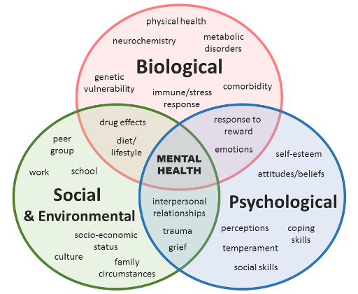
Figure 1: The Biopsychosocial Model. Based on the diagram from Open Learn, The Open University.
There are many different variations to Figure 1. But what they all have in common is the three-way Venn diagram overlap between the biological, the psychological and the social including the environmental. At its centre there is “mental health”. This source is a web page on anxiety and depression and so it places mental health in the centre. Other variants have a more general well-being in the centre. In each of the cells of the Venn diagram are different components to consider. One can perfectly reasonably understand the difficulty the healthcare professional has regardless of the field they specialise in. For example, I would not expect the psychologist or the social worker to understand much that is found in the ‘Biological’ cell.
I prefer to use the diagram in figure 2 as my basic understanding of the biopsychosocial model. There are some technical terms. ‘Cognitive’ means thinking', ‘somatic' refers to the body or the physical aspect.' ‘Behavioural' is the word used meaning ‘Acting and doing.’ ‘Emotional means being ‘emotional. The social environment refers to everything in the ‘Social and Environmental’ cell in Figure 1, and more besides.
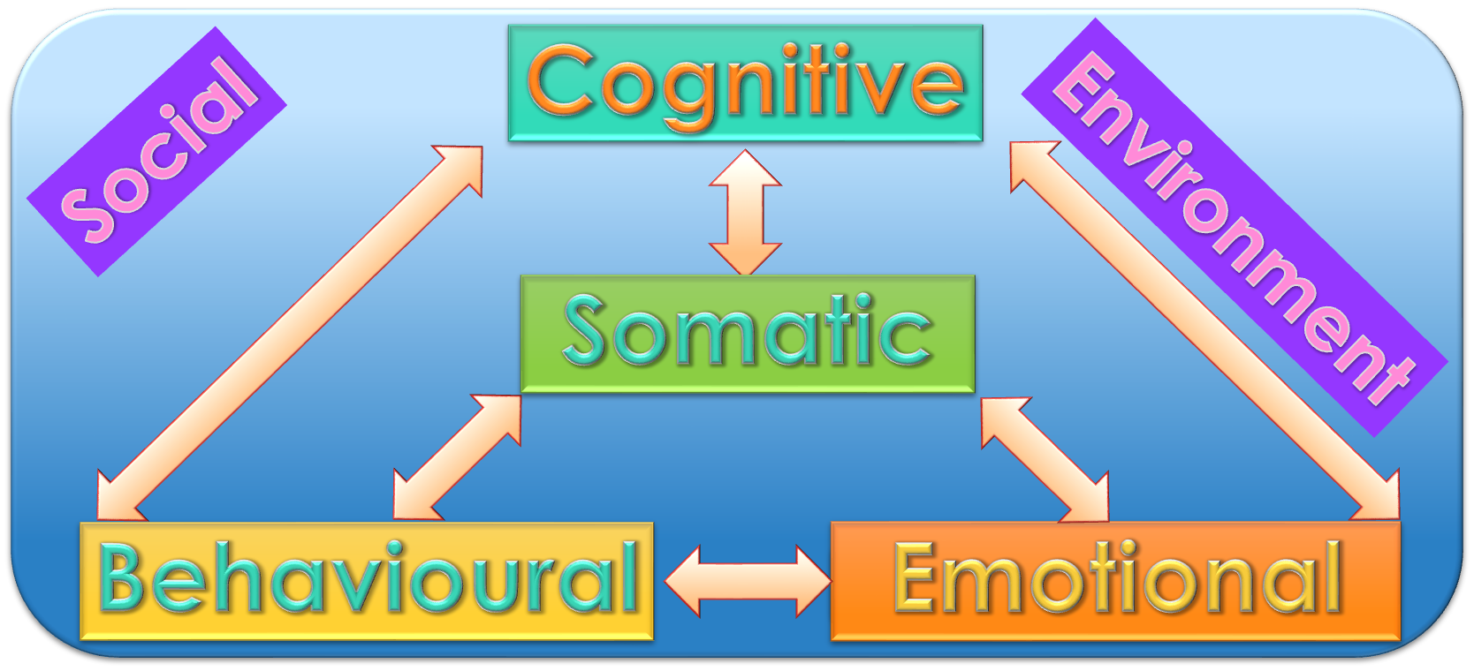
Figure 2: a more dynamic understanding of the biopsychosocial model.
The Psychological
The concept of the basic cognitive triad is a fundamental framework that explores the interplay between cognitions, behaviours, and emotions. These three elements are intricately linked, forming a dynamic system that can either create a virtuous circle of positive mental well-being or a vicious circle of negative patterns.
Insert here about the cognitive triad and Beck’s negative Cognitive triad of depression. Literature sounds confusing.
Understanding the relationship between each of the components of this triad is crucial for individuals seeking to improve their overall mental health and well-being. By recognizing how these elements influence one another, we can gain valuable insights into our thoughts, actions, and feelings. Of course for everybody the detail is individual but in general terms positive thinking leads to improved actions and emotions, improved actions lead to improved thinking and emotions, and improved emotions lead This is to improved thinking and actions.
By gaining a comprehensive understanding of this basic cognitive triad, individuals can begin to identify unhealthy patterns and make positive changes in their lives. Whether it's breaking free from negative thinking patterns; or adopting healthier behaviours; or develop the ability to manage and utilise our emotions to enhance emotional well-being, this knowledge empowers individuals to guide themselves to a more balanced and fulfilling life.
Somatism
‘Somatic’ or ‘somatism’ pertains to the body. Being somatic refers to the ability of connecting with and paying attention to the sensations and experiences within our physical bodies. It involves being fully present in the here and now, and acknowledging the wisdom that our bodies hold. By developing somatic awareness, we can gain a deeper understanding of ourselves, including our emotions, and our overall well-being.
Examples of somatic practices include yoga, tai chi, dance, and mindful movement. These practices encourage us to tune into the sensations in our bodies, to notice areas of tension or discomfort, and to explore ways of releasing or transforming these sensations through movement or breath. But these sensations may also
In addition to these formal practices, being somatic can also be as simple as taking a few moments throughout the day to check in with your body. This might involve noticing your breath, feeling your feet on the ground, the back and seat of the chair you are sitting on, or bringing awareness to any physical sensations that arise.
Being somatic should not be confused with being symptomatic, even though both refer to awareness of sensations in the body. Being symptomatic implies, becoming aware of a physical ailment. Being somatic refers to either being aware of healthy physiological processes or messaging from the mind via the body
The connection between mind and-body, our physical and mental well-being is slowly gaining acceptance, although there is still a long way to go. It is moving away from the more traditional mind-body dualism thinking.
When we talk about the interconnectedness of the physical with the cognitive, behavioural, and emotional aspects of ourselves it forms what I think of as a bio-psychological tetrahedron. Each component plays its own role in shaping who we are and how we experience and respond to the world around us.
Just as with the cognitive triad, we find that by undermining any one aspect of the bio-psychological tetrahedron - be it the physical or psychological - we inadvertently compromise the others.
For example, the person who has a severe pain but does not know what its cause is may well be worried about it. Even if known and it is severe enough and persisted for long enough the person will become depressed. Furthermore, depression itself causes heightened awareness of pains from known physical origin.
On the flip side, making conscious efforts to improve any aspect of the bio-psychological tetrahedron can yield significant benefits across the board. For example, it is known that taking physical exercise can improve our mood in mild anxiety or depression. Similarly, if we improve our mood, we can find ourselves having more physical energy.
Social and Environmental
In the complex web of human existence, there exists this profound interplay between our social and environmental surroundings and the intricate workings of our minds and bodies. If we extend up from the triangle to the tetrahedron, this interconnection forms a bio-psychosocial hyper-tetrahedron, where the physical, cognitive, behavioural, emotional, and social and environmental aspects are considered the whole. It is within this multidimensional framework that we begin to understand the bi-directional relationship between the various points of our somatic and psychological experiences and the influences of our external world. And the influence we have on it.
The concept of a pentagram in a pentagon serves as another apt and possibly easier to understand metaphor for this intricate relationship. (Figure 3) Just as four points on the pentagram represents one aspect of our being – Physical, Cognitive, Behavioural, and Emotional, so the final point represents the Social & Environmental. Together, they form an interconnected system whereby every facet is impacting on the others.
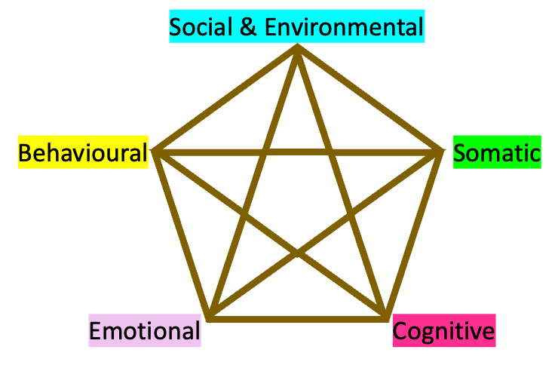
Figure 3: A pentagram in a pentagon representing the 5 corners and the inter-relationships of the bio-psycho-social model
It probably matters little whether we think of this five-way relationship as the physical and psychological person in the environment; or as an equal part with the environment in some much larger whole. There will be times when the one concept will work better than the second, and other times when it will be the reverse.
Regardless, understanding this holistic perspective allows us to appreciate the importance of considering external factors such as social relationships and environmental conditions when assessing an individual's well-being. The difference to the person who is supported by his surroundings as opposed to the one being undermined by them is immense. Additionally, it teaches us and emphasises that through our minds and bodies we can for better or worse shape our environment.
In healthcare this perspective encourages interdisciplinary collaboration across fields such as medicine, psychology, sociology, and environmental science to foster a deeper understanding and ultimately the betterment of human experiences.
So, is that all there is to being holistic and practicing holistically? Not quite. The bio-psychosocial model is the minimum requirement. There are two other major components that need to be considered separately.
Cultural
Culture is a multifaceted concept that encompasses various aspects of human life, including religion, traditions, societal norms, and shared values. It plays a crucial role in shaping our identities and influencing our behaviours. It can shape our bodies, literally. It is a social phenomenon that is deeply ingrained in our lives, so much so that we take for granted the culture into which we are born is the norm. And, as can be seen in Figure 1, Culture is considered as part of the Social & Environmental aspect of the Bio-psychosocial model.
Its inclusion here for special consideration is because, it is not limited by geographical boundaries. Factors such as immigration or historical influences can result in one society encompassing multiple cultures while one culture can exist across various societies when shared values transcend national borders. Indeed, one person can be a blend of many different cultures. For example, a research scientist of Asian background having come to a new country to study and continue his work will have absorbed the patterns of thought from his childhood, his faith, his naturalised country and the scientific community he works in.
Religion often acts as an integral part of many cultures, providing individuals with a set of beliefs and practices that guide their way of life. Religious and non-religious cultures alike can influence the worldview, moral values, and social interactions of their respective protagonists.
Cultures may be healthy or unhealthy. Healthy cultures are characterized by inclusivity, tolerance, everybody is valued, and respect for individual differences. They promote social cohesion and harmony among the community members. On the other hand, unhealthy cultures may exhibit exclusionary practices, foster a “we are better than they are” attitude or promote oppressive ideologies that hinder personal growth and societal progress.
Some cultures, and not necessarily the unhealthy ones, demand of potential new affiliates a test of behaviour and belief. This would be for the established adherents to the culture to assure themselves that any new recruits will maintain the values and customs of the culture. Examples would be religious conversion, naturalisation into a new country or dress codes at work.
Within healthcare as a general rule, when the care provider meets the client for the first time there will be certain expectations how each will behave and react to each other. The cultural norms that they share will be the basis of the ensuing interaction. When they come from the same culture those expectations are mutual. But there are many societies, that have many different ethnic cultures. It is therefore only natural for caregivers and their clients belonging to the same culture to gravitate towards each other. This is to be encouraged. Caregivers often develop close relationships with their customers based on trust and understanding. By recognizing and appreciating the cultural backgrounds of their customers, one barrier to communication is removed and caregivers can offer more personalized care based on this better understanding.
Spiritual
In addition to the biopsychosocial framework another term used in the context of being holistic is, ‘mind, body and spirit’. Contrasting these ideas, it may be considered that the mind equates with the psychological and the body with the biological, but how does the spirit fit in, in a useful context?
Spirituality appears to be a concept that goes beyond the physical and psychological. It delves into a deeper understanding of our inner selves including the realms of personal growth, self-discovery, inner peace, and the intangible and transcendent. It allows us to tap into our innermost feelings and find meaning in our experiences. For some, emotionality, including empathy, play a significant role in spirituality as it involves exploring and being sensitive to the deepest emotions of ourselves and others and connecting with them on a profound level.
For many years, I defined the human spirit as that part of us that gives us free will. Notwithstanding that now scientists believe that the perception of free will is an illusion; perhaps spirituality provides us with guidance and insights that can help us navigate through life's challenges. So, in addition to being the ability to explore our inner selves, perhaps it offers an individual framework and access point to connect with something greater than ourselves, but ultimately exercise our free will in alignment with higher principles or values.
There are two relevant concepts within such a framework. The first is interconnectedness; not only being deeply connected within ourselves; but also, to the people we come into contact with, those we do not and the universe. Many years ago, when I was writing a blog for all the psychosocial practitioners in the team that I was part of, I did a survey on what people understood by spirituality. At the top of the list as the most often cited was “Connectedness”, both connected to within oneself but also to others.
The second concept is that of higher principles or values. I believe this is what religions have set out to do; tap into the people’s sense of spirituality, and through principles, beliefs and rituals, guide their devotees through life.
But spirituality and religiousity are not synonymous. Religiousity has two components. There is external religiousity referring to adherence to specific visible religious practices within organized religions. Internal religiousity refers to the belief system and the principles of faith. On the other hand, spirituality encompasses a broader perspective that extends beyond both types of religiousity, any particular religion or any belief system.
Indeed, spirituality is not and should not be seen as exclusive to those who identify as religious or hold specific beliefs. Atheists and agnostics can also experience spirituality in their own unique ways, and they are no less valid as for the theist. Spirituality for them may involve exploring deeper insights into themselves, finding purpose through personal growth, connecting with nature or humanity at large, or exploring existential questions without relying on notions of higher powers.
From a clinical perspective, spirituality can play a significant role in clinical practice, both in physical and psychological medicine. By incorporating spirituality into healthcare, be it overtly or covertly, practitioners can provide a more comprehensive and compassionate approach to healing. (Source) But there is only a little that is not addressed in the bio-psychosocial framework, and what is, because they are matters of faith are usually covered under religious practice or culture usually which is within the Social and Environmental aspect.
Examples of spiritual considerations within physical medicine, include the Jehovah’s Witness patient who is challenging the surgeon to operate without the back up of a blood transfusion. The Catholic lady who requests an obstetrician of similar faith when having problems in pregnancy to be confident that the clinical advice being given is coming from the same spiritual and moral paradigm. The Ward nursing staff who need to be aware of unconventional relationship dynamics that do not meet the expected norms. The clinician who is asked by the patient the following questions, “Why does it only happen to me?” Or “What have I done to deserve this? Perhaps these questions can be answered physically or psychologically, but probably inadequately. They are much more to do with the significance of the role or meaning in life and hence is coming from the person’s spiritual self. They are not straightforward questions to answer.
Nevertheless, spirituality techniques, although not formally widely employed, not only promote relaxation but also have been shown to improve physical health outcomes. For example, research has found that individuals who engage in regular spiritual practices experience reduced stress levels and improved immune function. (Source)
In psychological medicine, a spiritual therapist, and others not trained as such, may play a crucial role in helping individuals explore and integrate their spirituality into their overall well-being. They provide a safe and non-judgmental space for clients to delve into their spiritual beliefs, values, and experiences. Through various therapeutic techniques, such as guided imagery, hypnotherapy, mindfulness practices, and dialogue, spiritual therapists assist clients in deepening their understanding of themselves and finding meaning in life's challenges. may help clients navigate life's challenges with a deeper sense of purpose and resilience. (Source)
Perhaps the situation that brings spirituality to the fore of health care is in the cancer patient who all of a sudden is faced with their own mortality and asks what does it mean? Has my life been worthwhile? What do I still need to achieve? Will I be able to leave behind a legacy?
As Carl Jung pointed out "The decisive question for man is: Is he related to something infinite or not?" And "The privilege of a lifetime is to become who you truly are."
How does spirituality fit in with the bio-psychosocial framework? I can envisage it in many ways. The social aspect is the dimension that takes our physical and psychological self; and looks at its place in the outer world of our community, our cultures, and our planet. Perhaps therefore spirituality at the simplest level of understanding, is the dimension that takes our physical and psychological self; and explores the inner self with its connections, emotions, hopes, friendships, and values all trying to find meaning and purpose. Perhaps it takes it to a much deeper and more personal level than psychology alone would. I can also perceive this as the same dimension as Social and Environmental perhaps in the opposite direction. meeting itself at our metaphorical antipodes. Or perhaps Spirituality is the ‘glue’ that unites and keeps together the biological, the psychological and the social. Whichever is the best model, spirituality has never played much of a role in healthcare. Perhaps it needs to have greater prominence.
An example of Holistic Considerations
Sidney: Male Age late 20s-to-early 30’s mother alive though with multiple health problems, father of West Indian origin, whereabouts unknown. He had an easy-going personality. He was married with two sons. He attended sporadically for viral and respiratory infections that were not clearing by themselves. It was noted that he would show concern about his mother’s well-being but was not seen together with his wife or growing children.
In the next phase of his life, for his ailments he attended other doctors, but I met his second wife several times. She had no children either from Sidney or previously. She required psychological support because she was having difficulty coming to terms with his drink problem. Her attempts at having conversations with Sidney to change or seek help were falling on deaf ears. Her future happiness did not appear to remain connected to Sidney.
Now in his early 60s he developed heart failure and Systemic Lupus Erythematosus (SLE) He had swollen hands and ankles and had difficulty walking. His bed had been brought downstairs into the living room, where he spent most of his time. Even coming out of bed to sit in the easy chair was a challenge. He was depressed much of the time. He was looked after by his 3rd ‘wife’ who seemed up to the task.
The story of Sydney above in the box is very superficial with detail missing. But quite often this is the level of summary understanding that a physician will have. There will be more detail in the consultation that has been lost. Nevertheless, as a summary it gives the salient points that are relevant.
There are four age groups to consider. What is noteworthy is that throughout there is no reference to religion or meaningful spirituality, and perhaps this was lacking.
First is his childhood, before the synopsis begins. What was the relationship between his parents? What was the atmosphere like in the house between them? Did he have a meaningful relationship with any of his grandparents and was there any cultural influences, for better or worse from the West Indian side of his family? What was the relationship between Sidney and his father? Why did his father leave home? Was this the biggest trauma he faced or was there something else that did not come to light? Did Sydney have a father figure from whom he could develop his sense of being a supportive husband and father? Possibly not.
Moving onto his first marriage, perhaps not having a good parental image was the source for him appearing to neglect his family. If he was having a drink problem later in life, did it start at this stage? Probably as it needs time to develop. We then have further questions. What additional stresses was he under? Was it because of those stresses that he resorted to alcohol? Or that once he had started, he was not able to put the drink down? What insight, if any, was he having into his own personality, behaviour and emotions? Was he able to think deeper than just his thoughts alone? What values in life was he adhering to and what values perhaps were weak or lacking?
Moving onto his second marriage, although they did not have any children, was he repeating the same mistakes? What other questions were raised? While perhaps his wife was being seen, what support, advice or counselling was he himself receiving? What health problems was he potentially letting himself in for? This relationship too, clearly was not going to survive the test of time. How did it end? Was there a final event?
And into the final stage, with his third wife. An independent life has clearly collapsed by now. How old was he and where did he meet his third wife? It is not clear how much time if any they had while he was in good physical health. He clearly has good inter-personal skills being able to meet and form relationships with caring women. What support does she need to be able to support him? Regular district nursing support was being provided which was a help Was he receiving all the Social Security benefits that he was entitled to? Was the heart failure due to alcoholic cardiomyopathy or part of the SLE condition? Or both? SLE is an autoimmune condition in which the body’s own immune system is attacking itself. Was this condition representing some deeper aspect of his mind where unexpressed emotions were finding their outlet through his physical body?
There are several points worth noting. Laying out his life trajectory in this manner is very different to when a clinician sees him for 10-15 minutes every so often. It would appear that there was a steady decline from childhood were the seeds were sewn that eventually culminated in his serious physical illnesses in his early 60s. This is not unusual. It is very often that many years pass when the antecedents to a problem occur well before its manifestation.
And yet given standard practice, was there an opportunity to intervene? At the time probably not. Nothing has emerged that would alert social services, even by today’s standards. The teachers at schools too, may well not have detected anything. When it comes to recognising the contribution or the impediments that the child’s background can have on his education, teachers and social workers today are much more tuned into the needs of the child than those in the 1960s and 70s.
Conclusions and final thoughts
The very minimum for any practitioner to consider themselves as being holistic, is to consider the disciplines of the physical, the psychological and the social in terms of the biopsychosocial model. Furthermore, they need to develop their own ability to look inwardly at themselves and with full honesty be aware of their own strong points and weaknesses. Genuine holistic practitioners cannot afford to have weak areas. But at the same time only a very few may achieve mastery in all these necessary disciplines. Being able to learn about areas not the forte is important.
Those in the best position are general practitioners or family physicians. I like the term family physician as it encompasses both the physical nature of what is being cared for and the psycho-social setting in which the person resides. It also implies that there is caring for a family and not just an individual. Thus, when a clinician sees one patient but is also responsible for the care for their relative, even though one may be in the consulting room and the second elsewhere the advice given to the one should also be good advice for the second.
As per recommendation of The Royal College of General Practitioners, family physicians are trying to move from a consultation length of a 10-minute appointment up to 15 minutes but if we start adding in spiritual components even 15 minutes will be inadequate. And yet introducing spirituality into a consultation, must at some point in the future also be part of the way forward.
References
Holistic References
Riley DS, Anderson R, Blair JC, Crouch S, Meeker W, Shannon S, Sudak N, Thornton L, Low Dog T. The Academy of Integrative Health and Medicine and the Evolution of Integrative Medicine Practice, Education, and Fellowships. Integr Med (Encinitas). 2016 Mar;15(1):38-41. PMID: 27053935; PMCID: PMC4818068.
Complementary And Alternative Medicine Market Size, Share & Trends Analysis Report By Intervention (Botanicals, Mind Healing, Body Healing, External Energy, Sensory Healing), By Distribution Method, By Region, And Segment Forecasts, 2023 – 2030. https://www.grandviewresearch.com/industry-analysis/complementary-alternative-medicine-market Accessed 9th July 2023.
Psychology references

Spirituality References:
Need checking
1. Smith, T.B., McCullough, M.E., & Poll, J. (2003). Religiousness and depression: Evidence for a main effect and the moderating influence of stressful life events. Psychological Bulletin, 129(4), 614-636.
2. Koenig HG et al., (2012). Religion/Spirituality And Health Outcomes: A Review And Synthesis Of The Meta-Analytic Evidence. Journal of Religion & Health 51(4), 1-16.
3. Jung CG (1938). Modern Man In Search Of A Soul.
4. Puchalski CM et al., (2019). Improving the Quality of Spiritual Care as a Dimension of Palliative Care: The Report of the Consensus Conference. Journal of Palliative Medicine 22(4), 458-473.

Holistic taking an interest in the person

Bio-psycho-social

Standard model

Include Cultural

Include Spiritual

Case study

This intricate web reminds us that addressing one dimension alone is not sufficient for holistic well-being.

In today's fast-paced and interconnected world, the concept of practicing holistically has gained significant attention. Being holistic means considering all aspects of a person's well-being, including their physical, psychological, social, spiritual, and cultural dimensions. It is an approach that recognizes the interconnectedness of these various aspects and seeks to address them in a comprehensive manner.
When we talk about practicing holistically, we are referring to the idea of taking a balanced and integrated approach to our health and well-being. It involves nurturing not only our physical bodies but also our mental and emotional states, as well as our relationships with others and our connection to something greater than ourselves.
By adopting a holistic perspective, we recognize that each aspect of our lives has an impact on the others. For example, if we neglect our physical health by not exercising or eating well, it can have negative effects on our mental and emotional well-being. Similarly, if we neglect our social connections or spiritual needs, it can lead to feelings of isolation or a lack of purpose.
Practicing holistically means actively seeking to cultivate harmony and balance in all areas of life. It involves engaging in activities that promote physical fitness, such as exercise and proper nutrition. It also entails taking care of our mental health through practices like mindfulness meditation or therapy. Additionally, it includes nurturing meaningful relationships with others and exploring our own spirituality or connection to something greater than ourselves.
In conclusion, practicing holistically is about recognizing the interplay between different aspects of our lives and taking proactive steps towards achieving overall well-being. By embracing this approach, we can lead more fulfilling lives that are aligned with who we truly are at every level: physically, psychologically, socially, spiritually, and culturally.

Refs and further reading:
https://www.open.edu/openlearn/science-maths-technology/exploring-the-relationship-between-anxiety-and-depression/content-section-2. Viewed 2nd July 2023.

